Experiment Number : 10 Date: 25.02.2026

Implementation of Access Modifiers in Java

Aim:
Write a Java program to implement different access modifiers.

PRE LAB EXERCISE
QUESTIONS
- What are the 4 access modifiers available in Java?
Java provides four access modifiers that control the visibility of classes, variables, methods, and constructors. These are public, protected, default, and private. The public access modifier allows a class member to be accessed from anywhere in the program, even from different packages. The protected modifier allows access within the same package and also to subclasses (even if they are in different packages). The default access modifier (when no modifier is specified) restricts access only within the same package. The private modifier provides the highest level of restriction, allowing access only within the same class where it is declared. These modifiers help in achieving data hiding and encapsulation in Java.

- Which access modifiers can be used in Java to control access to class members?
To control access to class members (such as variables, methods, and constructors), Java allows the use of public, protected, private, and default access modifiers. The public modifier makes the member accessible from any other class. The protected modifier allows access within the same package and to subclasses. The default modifier allows access only within the same package when no access specifier is mentioned. The private modifier restricts access strictly to the class in which the member is declared. These access modifiers ensure proper security and controlled interaction between different parts of a Java program.

IN LAB EXERCISE
Objective
To demonstrate different access modifiers such as Default, Private, Protected and Public using Java programs.
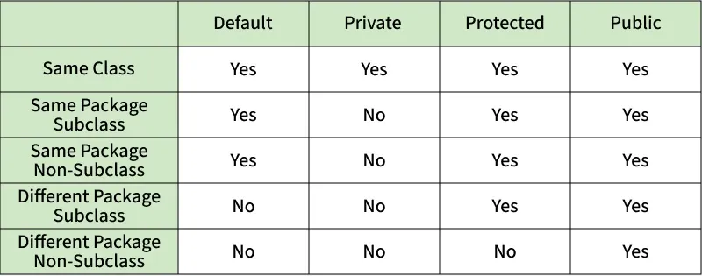
Fig: Comparison table of Access Modifiers in Java
Source Code
// Default Access modifier
class Car {
String model; // default access
}
public class Main {
public static void main(String[] args){
Car c = new Car();
c.model = "Tesla"; // accessible within the same package
System.out.println(c.model);
}
}
Output:
Tesla
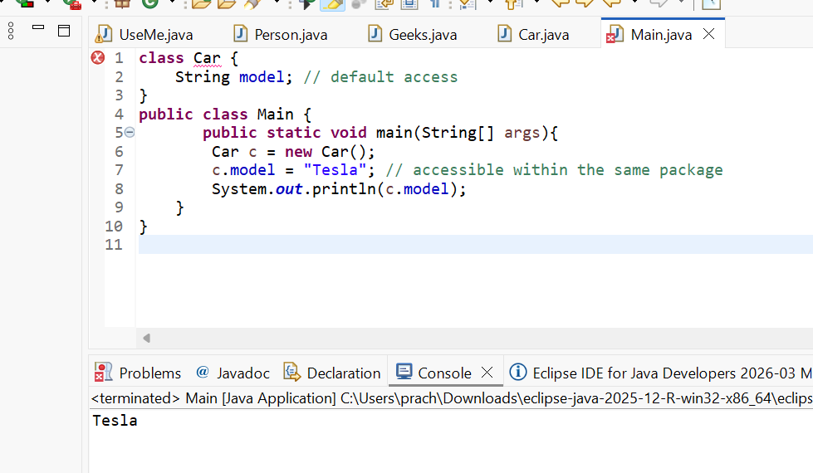

//Private Access Modifier
class Person {
// private variable
private String name;
public void setName(String name) {
this.name = name; // accessible within class
}
public String getName() {
return name;
}
}
public class Geeks {
public static void main(String[] args)
{
Person p = new Person();
p.setName("Alice");

// System.out.println(p.name);
// Error: 'name'
// has private access
System.out.println(p.getName());
}
}
Output
Alice
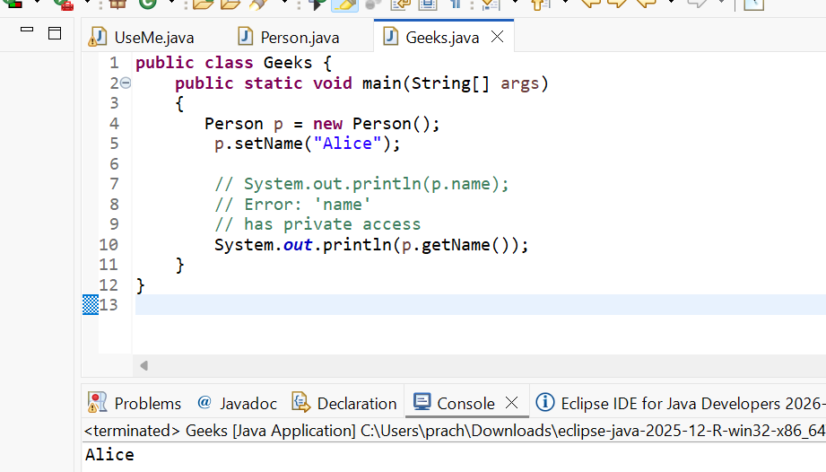

//Protected Access Modifier
class Vehicle {
protected int speed; // protected member
}
class Bike extends Vehicle {
void setSpeed(int s)
{
speed = s; // accessible in subclass
}
int getSpeed()
{
return speed; // accessible in subclass
}
}
public class Main {
public static void main(String[] args){
Bike b = new Bike();
b.setSpeed(100);
System.out.println("Access via subclass method: "+ b.getSpeed());
Vehicle v = new Vehicle();
System.out.println(v.speed);
}
}
Output
Access via subclass method: 100
0
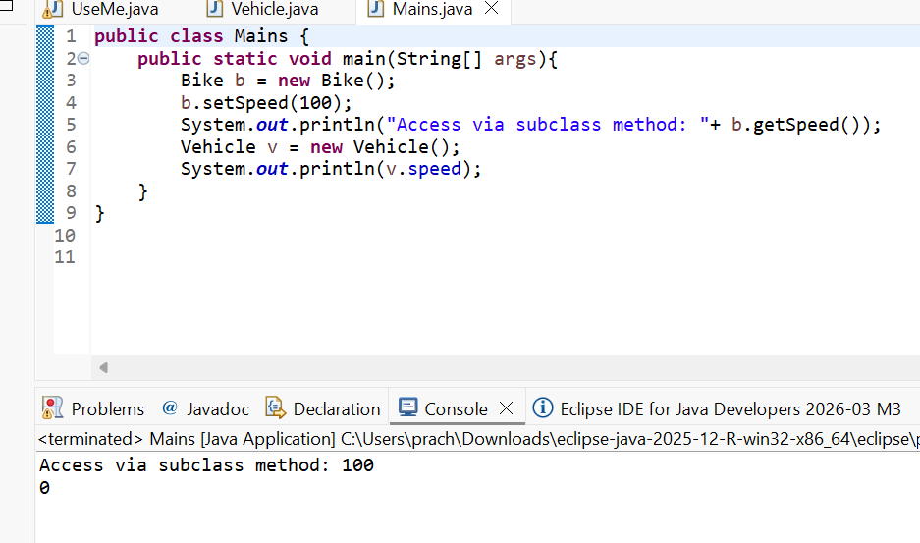

//Public Access Modifier
class MathUtils {
public static int add(int a, int b) {
return a + b;
}
}
public class Main {
public static void main(String[] args) {
System.out.println(MathUtils.add(5, 10)); // accessible anywhere
}
}
Output
15
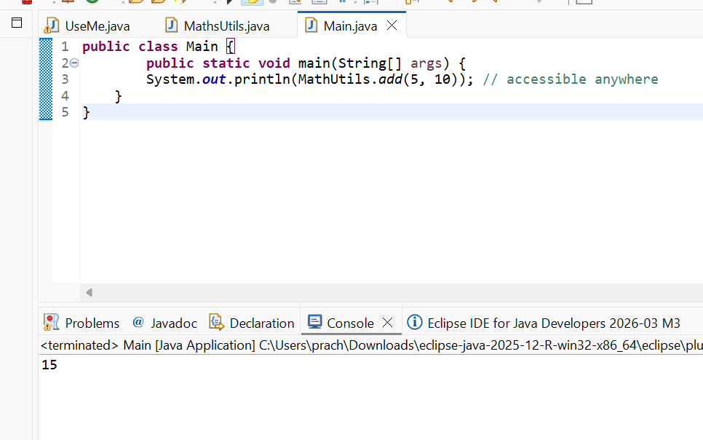

POST LAB EXERCISE
  - Write a Java program to implement Default access modifier which has a default class within the same package and a default class from a different package.
The default access modifier in Java is applied when no access specifier is declared for a class, method, or variable. It restricts the visibility of the class or member to only within the same package. In the program, a default class is created in one package and accessed by another class within the same package successfully, which demonstrates that default access allows visibility inside the package. However, when attempting to access the same default class from a different package, a compile-time error occurs because default access does not permit access outside its package. Thus, the default access modifier ensures that classes and members are accessible only within the same package and not beyond it.

  - Which access modifier provides the highest level of access?
The public access modifier provides the highest level of access in Java. A public class, method, or variable can be accessed from anywhere in the program, whether within the same package or from a different package. There are no restrictions on visibility when public is used. It allows full accessibility across all classes and packages in a Java application. Therefore, among all access modifiers (public, protected, default, and private), public provides the widest and highest level of access.

ASSESSMENT

Description | Max Marks | Marks Awarded
Pre Lab Exercise | 5
In Lab Exercise | 10
Post Lab Exercise | 5
Viva | 10
Total | 30
Faculty Signature

Experiment Number :11 Date: 26.02.2026

Implementation of multiple inheritance in Java using Interface

Aim:
Write a Java program to implement multiple inheritance using Interface.

PRE LAB EXERCISE
QUESTIONS
- Why Java does not support multiple inheritance using classes like that of C?
Java does not support multiple inheritance using classes to avoid ambiguity and complexity, especially the Diamond Problem. In multiple inheritance, if two parent classes contain a method with the same name and the child class inherits from both, the compiler becomes confused about which method to execute. This creates ambiguity and increases complexity in method resolution. To maintain simplicity, readability, and reliability, Java avoids multiple inheritance through classes. Instead, Java supports multiple inheritance using interfaces, where method implementation conflicts can be controlled more clearly.
- What is the primary purpose of an interface in Java?
- To store data using instance variables
- To define a contract of methods a class must implement
- To allow creation of objects
- To improve runtime performance
Answer:
B. To define a contract of methods a class must implement

IN LAB EXERCISE
Objective
To demonstrate how an interface in Java defines constants and abstract methods, which are implemented by a class.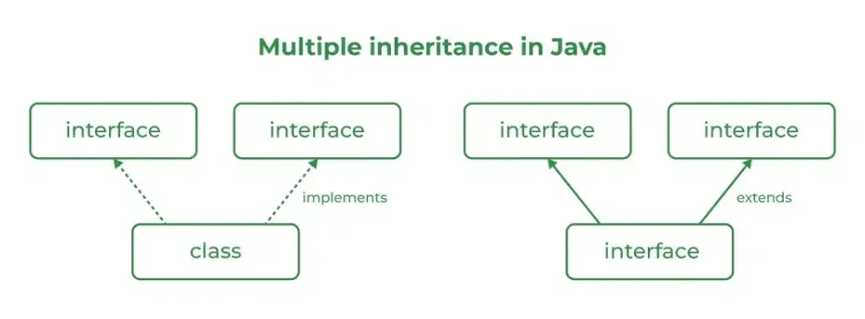

Source Code
import java.io.*;
// Add interface
interface Add{
int add(int a,int b);
}
// Sub interface
interface Sub{
int sub(int a,int b);
}
// Calculator class implementing Add and Sub
class Cal implements Add , Sub
{
// Method to add two numbers
public int add(int a,int b){
return a+b;
}
// Method to sub two numbers
public int sub(int a,int b){
return a-b;
}
}
class Example{
// Main Method
public static void main (String[] args){

// instance of Cal class
Cal x = new Cal();
System.out.println("Addition : " + x.add(2,1));
System.out.println("Substraction : " + x.sub(2,1));
}
}

Outputs
Addition : 3
Subtraction : 1
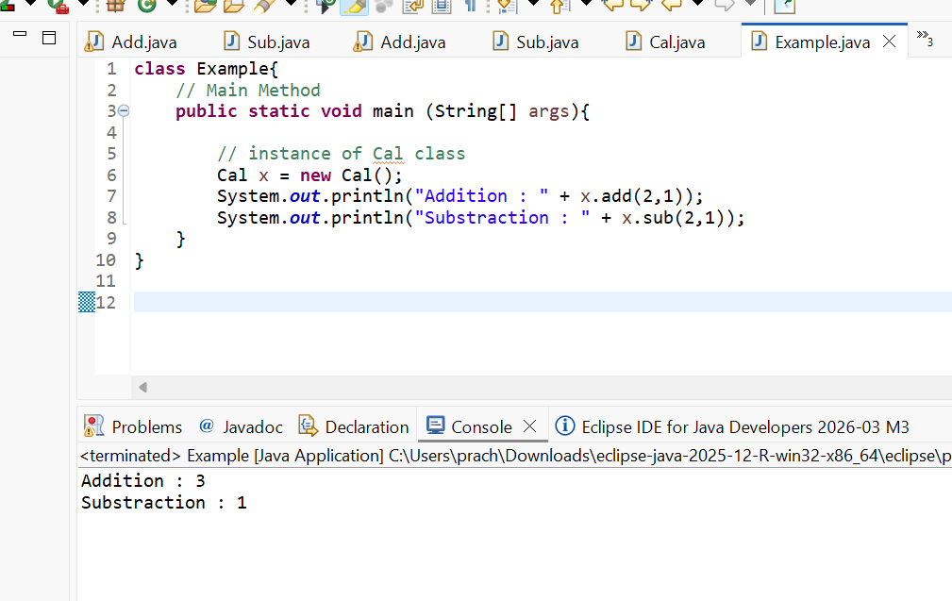

POST LAB EXERCISE
  - Can a functional interface extend another interface?
Yes, a functional interface can extend another interface, provided that the total number of abstract methods after inheritance remains exactly one. If the parent interface contains one abstract method and no additional abstract methods are added, the child interface can still be considered a functional interface. However, if more than one abstract method is inherited or declared, it will no longer qualify as a functional interface.

  - Which feature was introduced in interfaces starting from Java 8?
- Constructors
- Private methods
- Default and static methods
- Final classes
C. Default and static methods.
Starting from Java 8, interfaces were enhanced to include default and static methods. Default methods allow interfaces to provide method implementations without breaking existing classes, while static methods enable utility functionality within the interface itself.

ASSESSMENT

Description | Max Marks | Marks Awarded
Pre Lab Exercise | 5
In Lab Exercise | 10
Post Lab Exercise | 5
Viva | 10
Total | 30
Faculty Signature

Experiment Number : 12 Date: 26.02.2026

Implementation of exception handling in Java
Aim:
Write a java program to implement exception handling.

PRE LAB EXERCISE
QUESTIONS
- What is exception handling in Java?
Exception handling in Java is a mechanism used to handle runtime errors so that the normal flow of the program can be maintained. It allows a program to detect and manage unexpected situations, such as division by zero or invalid input, without crashing. Java provides keywords like try, catch, finally, throw, and throws to handle exceptions effectively.

- What is the purpose of using try-catch blocks in exception handling?
The purpose of using try-catch blocks is to catch and handle exceptions that may occur during program execution. The try block contains code that might generate an exception, while the catch block handles the exception and prevents the program from terminating abruptly. This ensures that errors are managed properly and the program continues to run smoothly

IN LAB EXERCISE
Objective
To understand and implement exception handling through try-catch and finally blocks.
Source Code
import java.util.InputMismatchException;
import java.util.Scanner;
public class ExceptionHandlingExample {
public static void main(String[] args) {
Scanner scanner = new Scanner(System.in);
try {
System.out.print("Enter an integer: ");
int num = scanner.nextInt();
int result = 10 / num;
System.out.println("Result: " + result);
} catch (InputMismatchException e) {
System.out.println("Invalid input! Please enter an integer.");
} catch (ArithmeticException e) {
System.out.println("Cannot divide by zero!");
} finally {
scanner.close();
System.out.println("Program execution completed.");
} }
}
Outputs
Output 1 (Valid Input - Non-zero Integer):
Enter an integer: 5
Result: 2
Program execution completed.
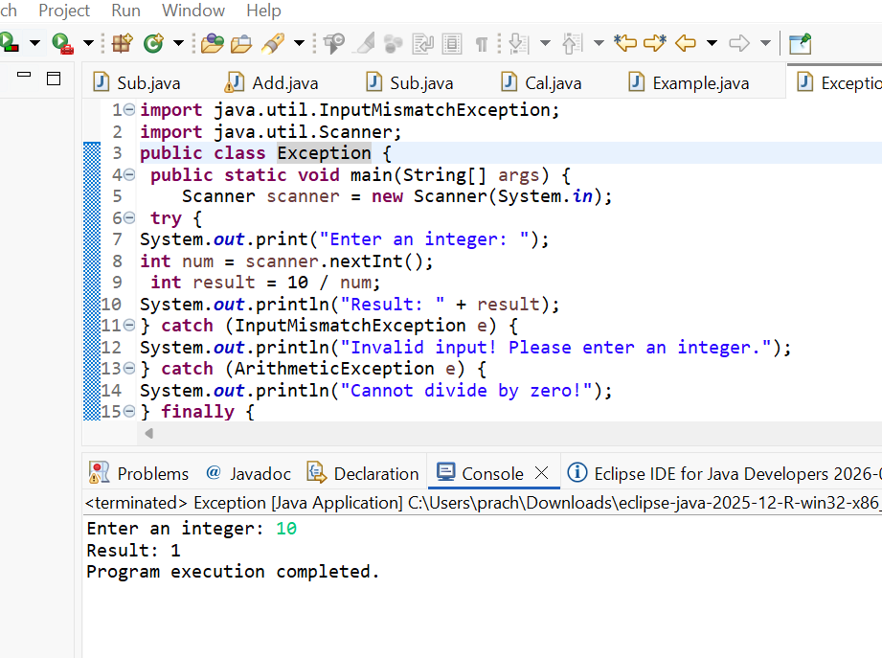

Output 2 (Valid Input - Zero):
Enter an integer: 0
Cannot divide by zero!
Program execution completed.
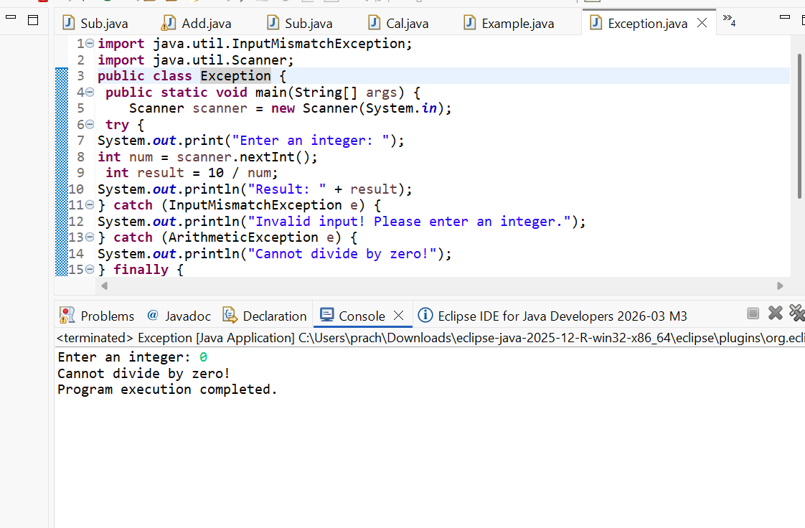

Output 3 (Invalid Input - Non-integer):
Enter an integer: abc
Invalid input! Please enter an integer.
Program execution completed.
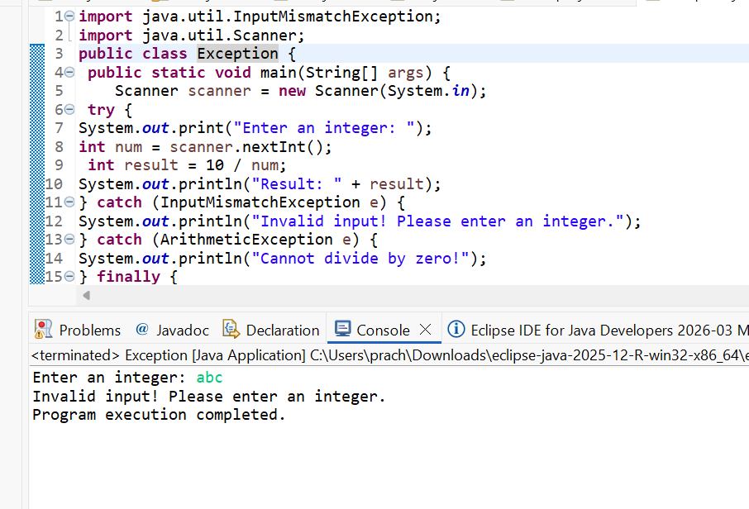

POST LAB EXERCISE
- What is the purpose of the Scanner object in the Java program?
The purpose of the Scanner object in a Java program is to take input from the user at runtime. It is commonly used to read different types of data such as integers, floating-point numbers, and strings from the keyboard. The Scanner class, which belongs to the java.util package, helps in processing and parsing user input efficiently.

- What exceptions are expected to be thrown in the code within the try block? Why?
The exceptions expected to be thrown in the try block usually include ArithmeticException and InputMismatchException, depending on the code. An ArithmeticException may occur if a number is divided by zero, while an InputMismatchException occurs when the user enters input of an incorrect data type (for example, entering a string instead of an integer). These exceptions are handled to prevent the program from crashing and to ensure smooth execution.

ASSESSMENT

Description | Max Marks | Marks Awarded
Pre Lab Exercise | 5
In Lab Exercise | 10
Post Lab Exercise | 5
Viva | 10
Total | 30
Faculty Signature

Experiment Number : 13 Date: 27.02.2026

Implementation of User-defined Exception in Java

Aim:
Write a java program to implement User-defined Exception.

PRE LAB EXERCISE
QUESTIONS
- What is Java custom exception?
A custom exception in Java is a user-defined exception created by extending the built-in Exception or RuntimeException class. It is used to handle application-specific errors that are not covered by predefined exceptions. Custom exceptions improve code clarity and allow developers to define meaningful error messages based on business logic requirements.

- What are the two types of custom exceptions in Java?
The two types of custom exceptions in Java are Checked custom exceptions and Unchecked custom exceptions. Checked custom exceptions are created by extending the Exception class and must be handled using try-catch blocks or declared using throws. Unchecked custom exceptions are created by extending the RuntimeException class and do not require mandatory handling at compile time.

IN LAB EXERCISE
Objective
To understand and implement Checked and Unchecked custom exceptions.
Source Code
Ex 1: // Custom Checked Exception
class InvalidAgeException extends Exception {
public InvalidAgeException(String m) {
super(m);
}
}
// Using the Custom Exception
public class AgeCheck{
public static void validate(int age)
throws InvalidAgeException {
if (age < 18) {
throw new InvalidAgeException("Age must be 18 or above.");
}
System.out.println("Valid age: " + age);
}
public static void main(String[] args) {
try {
validate(12);
} catch (InvalidAgeException e) {
System.out.println("Caught Exception: " + e.getMessage());
}
}
}

Output 1
Caught Exception: Age must be 18 or above.
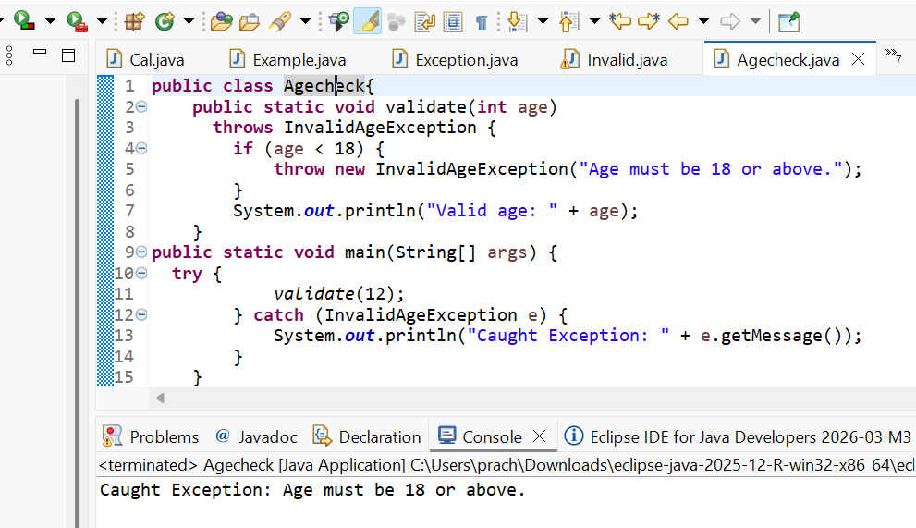

Ex 2: // Custom Unchecked Exception
class DivideByZeroException extends RuntimeException {
public DivideByZeroException(String m) {
super(m);
}
}
// Using the Custom Exception
public class TestSample {
public static void divide(int a, int b) {
if (b == 0) {
throw new DivideByZeroException("Division by zero is not allowed.");
}
System.out.println("Result: " + (a / b));
}
public static void main(String[] args) {
try {
divide(10, 0);
} catch (DivideByZeroException e) {
System.out.println("Caught Exception: " + e.getMessage());
}
}
}

Output 2
Caught Exception: Division by zero is not allowed.
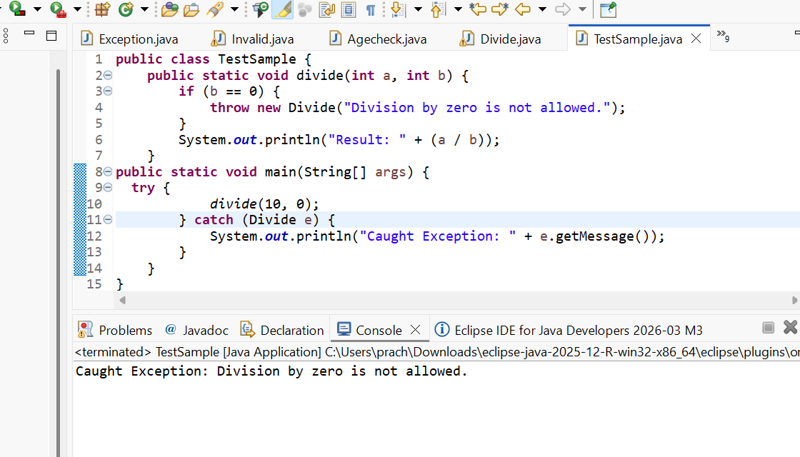

POST LAB EXERCISE
- What is required to create a custom exception in Java?
- Extend the Object class
- Extend the Throwable class
- Extend Exception or RuntimeException
- Implement the Serializable interface
C. Extend Exception or RuntimeException
To create a custom exception in Java, a class must extend either the Exception class or the RuntimeException class. If it extends Exception, it becomes a checked exception that must be handled or declared using throws. If it extends RuntimeException, it becomes an unchecked exception that does not require mandatory handling at compile time.

- List some use cases for the checked and unchecked exceptions.
Checked Exceptions (Compile-time exceptions):
Checked exceptions are used in situations where the program can reasonably recover from the error and the developer is forced to handle it. Common use cases include file handling operations (like FileNotFoundException), database connections (SQLException), network communication (IOException), and user input validation. These exceptions ensure that critical operations such as reading files or accessing external resources are properly handled to avoid program failure.

Unchecked Exceptions (Runtime exceptions):
Unchecked exceptions are used for programming errors or unexpected conditions that usually cannot be recovered from during runtime. Common use cases include dividing by zero (ArithmeticException), accessing invalid array indexes (ArrayIndexOutOfBoundsException), null object access (NullPointerException), and logical mistakes in code. These exceptions indicate bugs in the program that should be fixed rather than handled at runtime

ASSESSMENT

Description | Max Marks | Marks Awarded
Pre Lab Exercise | 5
In Lab Exercise | 10
Post Lab Exercise | 5
Viva | 10
Total | 30
Faculty Signature

